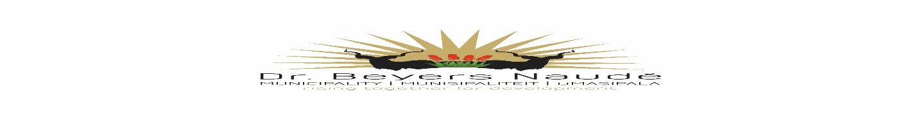
TENDER 89/2020
LEASE OF MUNICIPAL COMMONAGE LAND FOR GRAZING PURPOSES: NIEU BETHESDA

Tender documents will be available at a non-refundable deposit of R 100.00 from the Dr Beyers Naudé
Municipality at the SCM Building, Slabbert House, 11-13 Church, Graaff-Reinet or electronically, please contact 049 807 5761/40 or e-mail: jegelsr@bnlm.gov.za or koebergj@bnlm.gov.za

Bank details are as follow: Standard Bank, Account Number 332104192, Branch Number 050116, Branch Electronic Payment Code 051001, and Reference – 89/2020. Proof of payment should be provided upon tender collection.

Tenders must be placed in the municipal tender box, Robert Sobukwe Building, in sealed envelopes clearly marked "89/2020", not later than 12h00 on Wednesday, 20 January 2021 and will be opened in public immediately thereafter.

Note:
- Faxed, e-mailed or late quotations will not be accepted.
- The tender will be evaluated on 80/20 system.
- A current original tax clearance certificate of SARS “or” Sars Verification pins to be supplied.
- Tenderers must submit certified copies of their identity documents.
- Tenderer to submit all returnable documents as per the special condition of contract.
- For further details contact Mr. H. Hendricks 049 807 5700
- This Bid is subject to the General Conditions of Contract (GCC) and, if applicable, any other Special Conditions of Contract.
- Council is not bound to accept the highest or any tender and reserves the right to accept any tender or part thereof.

This Bid will be evaluated and Adjudicated according to the following criteria
- Relevant specifications;
- Value for money;
- PPPFA Regulations 2017.
NB: NO BIDS WILL BE CONSIDERED FROM PERSONS IN THE SERVICE OF THE STATE, PROVINCIAL GOVERNMENT OR MUNICIPALITY.

DR. E.M. RANKWANA
MUNICIPAL MANAGER

