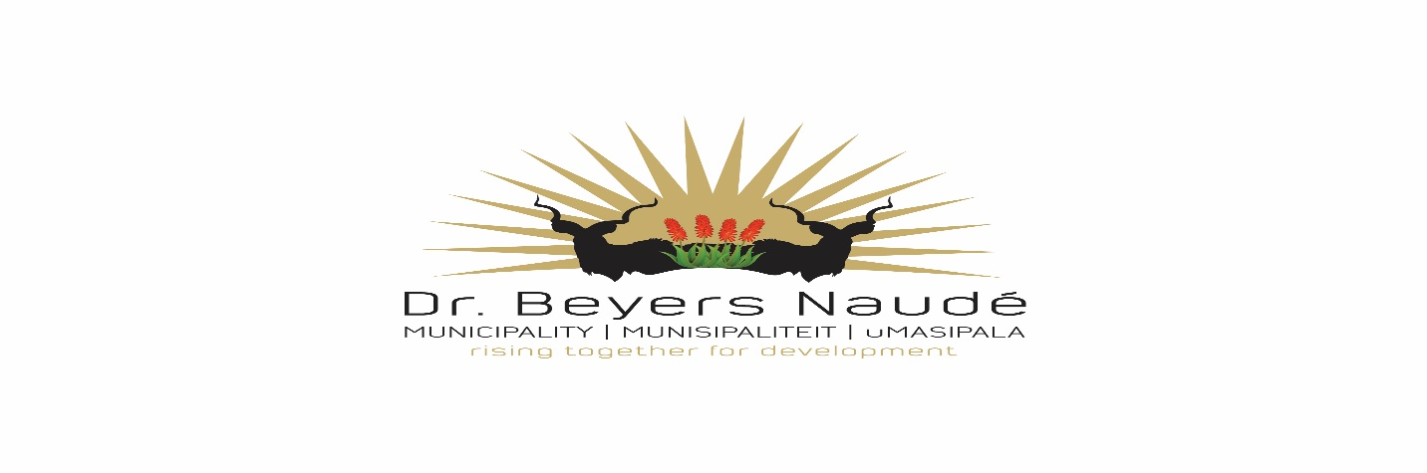
CLOSING DATE FOR BIDS OF PROVINCIAL LEGISLATURE AND CANCELLATION OF SITEMEETING SCHEDULED FOR 13 OCTOBER 2023

The annual program of The Legislature of Taking Legislature to the People (TLTTP) will be taking place in Graaff Reinet from the 23-27th of October 2023. To facilitate the program, certain items/services will be needed, whereby briefing sessions were held in Graaff Reinet on the 11th and 12th of October 2023.

The closing date for bids is Tuesday 10 A.M, Robert Sobukwe Building in the municipal tender box, in sealed envelopes marked TLTTP bids. No late bids will be accepted.

The Provincial Legislature has given notice that the briefing session scheduled for Friday the 13th of October at Botanical Sportsgrounds will no longer take place.

For further details please contact Mrs M Schoeman at mschoeman@eclec.gov.za

DR. E.M. RANKWANA
MUNICIPAL MANAGER
FOR ON BEHALF OF THE PROVINCIAL LEGISLATURE

