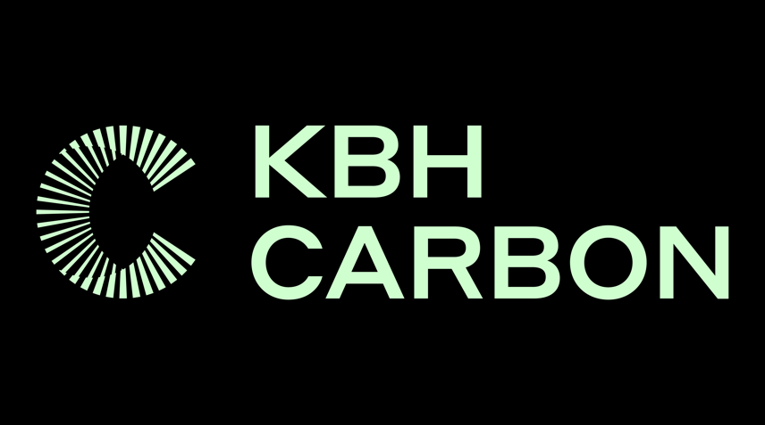

Community Update

KBH Carbon is committed to the sustainable harvesting of Portulaca Ria afra, commonly known as Spekboom. It has begun upskilling the local community to use naturally occurring Spekboom in the communal gazing areas within Steytlerville to supply KBH Carbon with cuttings.

Sustainable harvesting is NOT removing entire plants but selective light pruning of existing large shrubs. It is more sustainable than grazing and has less of an impact on the Spekboom plant, as (1) pruning takes place from 0.5 m upwards, (2) only small branchlets are pruned, and (3) the majority of the photosynthetically active material (i.e. leaves) are left on the plant. Meanwhile, grazing occurs from the bottom upwards, destroying the skirt, making the Spekboom vulnerable to the elements, and increasing runoff. The human harvesting can be considered to be akin to the top-down browsing method of elephants and other tall browsers that historically occurred in the thicket.

The operations of KBH Carbon currently involve a team of 60 -80 dedicated labourers. Their crucial role is to plant the cuttings which have been rooted in their nursery into the Uitkyk farm. This task is instrumental in the success of KBH Carbon’s rehabilitation and restoration project and, ultimately, the carbon sequestration part of the project.
The community's eagerness to begin supplying KBH Carbon with cuttings is evident, and it bodes well that the value of Spekboom’s will increase in the community.
KBH Carbon’s commitment to due diligence, supported by authorisation from the Municipality, is exemplified in our collaboration with Mr Hans Hendricks, who manages all communal areas in Dr Beyers Naude Municipality. Together, KBH Carbon is setting up the necessary paperwork and mechanisms for the community harvesting project, showcasing their shared vision for sustainable development. This update will also be placed on the municipal website.
Cuttings of 25 cm are to be harvested and put in bags of 200, which are then planted into trays to begin the rooting process. Dr Alastair Potts, Professor of Botany at Nelson Mandela University and chairperson of the Thicket Forum, has been consulted on creating a standard operating procedure for harvesting cuttings in communal areas to ensure the harvesting takes place sustainably. He once again praised this innovative approach to the greater restoration project and the openness of KBH Carbon to exploring new ideas within the industry.

The community is organising itself into a collective whereby the cuttings will
be paid to one entity, who will then pay his or her team accordingly.

KBH Carbon requested that regular audits be conducted to ensure that the SOP is being adhered to, and that there is cooperation with the Municipality and DEDEAT to implement this. Residents will be appointed to fulfil an auditing role, ensuring that harvesting is being done according to the standard operating procedure.
The beauty of the project is that, whilst there is rehabilitation of the land, there is also immense benefit for the local community by way of the employment opportunities which are created. The project will ultimately employs about 250 people which already benefit approximately 30 households. As the spekboom is plenty in Dr Beyers Naude Municipal area, the Municipality intends to work with other partners and stakeholders in the industry and expand this to other areas which means that more people will be able to benefit from this noble initiative. We want to emphasize that we will together with KBH Carbon continue taking great care of the environment through close cooperation with the Department of Economic Development, Environmental Affairs and Tourism.
Further reading on the matter can be found here:
For further reading on the subject:

- https://www.unep.org/news-and-stories/story/south-africa-reversing-land-degradation-would-lead-economic-gains-new-study
- https://www.unep.org/news-and-stories/story/big-potential-benefits-restoring-spekboom-thicket-ecosystems-south-africa
- New UN Decade on Ecosystem Restoration offers unparalleled opportunity for job creation, food security and addressing climate change (unep.org)
Attached are two scientific papers on harvesting Spekboom that have guided our approach to sustainable harvesting methods.
We are planning an Open Day in June, during which you will be invited to see the progress made in the last year and get a first-hand view of how we conduct the project.

Please contact Josh Gordon, Director of KBH Carbon and Farm Manager, with any questions. 078 159 5016 or josh@kbh.co.za.

Prof. Alastair Potts is available for any ecological queries that you may have Alastair.potts@mandela.ac.za.

Mr H Hendricks, Senior Manager Strategic Services in the Office of the Municipal Manager, can be contacted at 0828219112 or hendricksh@bnlm.gov.za.

DR E M RANKWANA
MUNICIPAL MANAGER – DR BEYERS NAUDE LOCAL MUNICIPALITY
03 JUNE 2024

