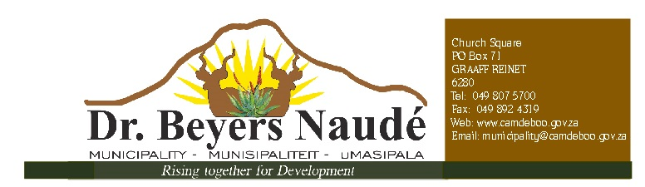
TENDER 106/2018
SUPPLY AND DELIVERY OF CLEANING MATERIAL OVER A PERIOD OF 12 MONTHS

Tender documents will be available at a non-refundable deposit of R 240.00 from the Dr Beyers Naudé Municipality, from the SCM Department, 11 Church Square, Graaff-Reinet, 6280, Tel nr 049 807 5730 / 87,
e-mail: nkohlat@bnlm.gov.za or booysend@bnlm.gov.za

Bank details are as follow: First National Bank, Account Number 52300007898, Branch Number 210216, Reference – Tender Number. Proof of payment should be provided upon tender collection.

Tenders must be placed in the municipal tender box, Robert Sobukwe Building, in sealed envelopes clearly marked "106/2018", not later than 12h00 on Friday, 14 December 2018 and will be opened in public immediately thereafter.

Note:
- Faxed, e-mailed or late quotations will not be accepted.
- Price to include VAT (if registered for vat) and disbursement costs involved with the project.
- The tender will be evaluated on 80/20 system.
- All suppliers must be registered on the CENTRAL SUPPLIER DATABASE. Log onto www.csd.gov.za for registration
- A current original tax clearance certificate of SARS “or” Sars Verification pins to be supplied.
- A current certified Municipal (rates & services) clearance certificate to be submitted.
- A current certified BBBEE status level certificate must be submitted in order to claim preference points.
  - If the Certificate is not attached to this tender document, no points shall be awarded for
B-BBEE status.
  - In the case of a Trust, Consortium or Joint Venture, they will qualify for points for their
B-BBEE status level as a legal entity provided that the entity submits their B-BBEE status level certificate.
- Council is not bound to accept the lowest or any tender and reserves the right to accept any tender or part thereof.
- For further details contact Mr. T. Nkohla or Ms D. Booysen at 049 807 5730 / 87
- This Bid is subject to the General Conditions of Contract (GCC) and, if applicable, any other Special Conditions of Contract.

This Bid will be evaluated and Adjudicated according to the following criteria:
- Relevant specifications;
- Value for money;
- PPPFA Regulations 2017
NB: NO BIDS WILL BE CONSIDERED FROM PERSONS IN THE SERVICE OF THE STATE, PROVINCIAL GOVERNMENT OR MUNICIPALITY.

DR. E.M. RANKWANA
MUNICIPAL MANAGER

