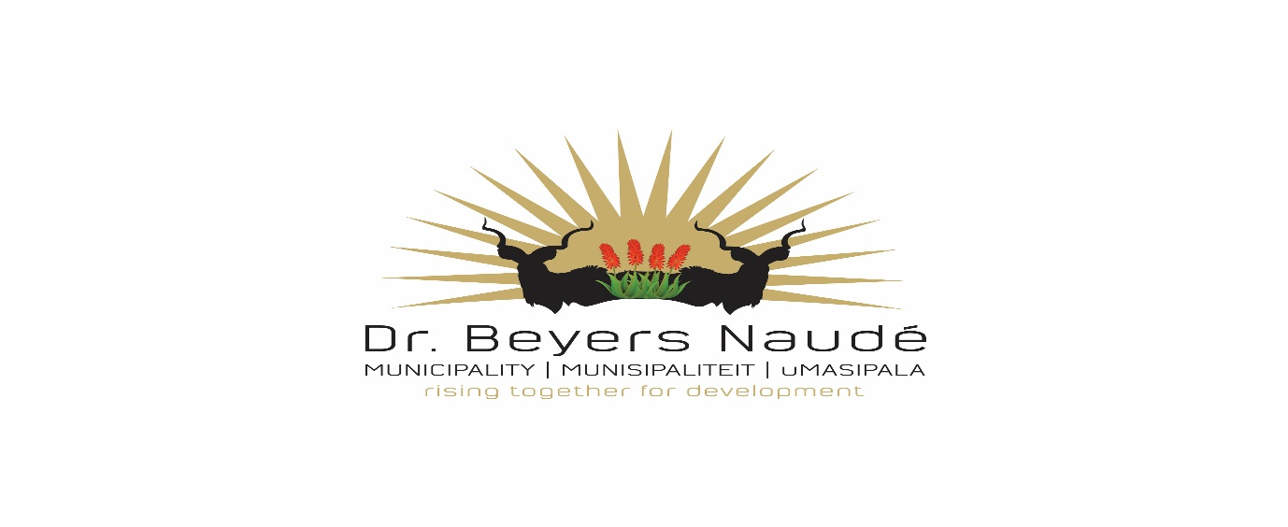
Memorandum
CANCELLATION: TENDER 52/2020: SALE OF INSTITUTIONAL, CHURCH ERVEN
Unfortunately due to changes in requirements the above mentioned tender had to be cancelled. The tender will be re-advertised.
Further enquiries could be directed to the SCM department, jegelsr@bnlm.gov.za

Kind Regards

Dr E.M Rankwana
Municipal Manager
Dr Beyers Naude Municipality

