INVITATION TO QUOTE: BEY SCM 359
Provision of Surveying Services – Consolidation and Subdivision of 65 Units for Nieu Bethesda Housing Projects

Quotations are hereby invited from registered and experienced Professional Land Surveyors for the consolidation and subdivision for the remainder of erven 44,45,46,47 and 48 in Nieu-Bethesda to create 65 units for a housing development

Background

The Dr Beyers Naudé Local Municipality in partnership with the provincial Department of Human Settlements has planned a Housing Projects in the area of Nieu Bethesda. The intention is to finalize the planning phase by way of creating a General Plan (GP) for the 65 planned units

Purpose

The purpose of this projects will be the following:
- To create 65 individual units and register the general plan at the Surveyor-General’s office by subdividing the remainder of erven 44,45,46,47 and 48 in Nieu Bethesda;
- This project must comply with the Dr Beyers Naudé Local Municipality SPLUMA BY-LAW related to the subdivision of land

Scope of Work

The project will consist of the following outcomes:
- Creation of a general plan to accommodate 65 units, as per the attached layout, register the layout at the Surveyor-General’s office by consolidating and subdividing the remainder of erven 44,45,46,47 and 48 in Nieu Bethesda.
- Provide the municipality with an original hard copy & electronic copy of the approved Surveyor-General diagrams

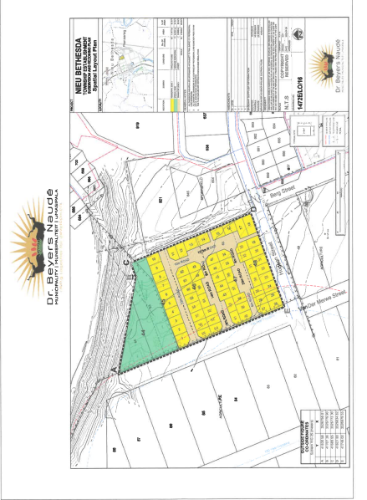

Quotes must be placed in the municipal tender box, Robert Sobukwe Building, in sealed envelopes clearly marked "BEY SCM 359 ", not later than 12h00, Wednesday on the 22th of February 2023 and will be opened in public immediately thereafter.
Note:
Faxed, e-mailed or late quotations will not be accepted.
- The tender will be evaluated on 80/20 system Whereby 80 points will be allocated for price and a maximum of 20 points for specific goals.
- To claim for specific goals prospective bidders MUST submit proof/required the required documents
- Price must include vat (if registered for vat) and delivery costs to Graaff-Reinet.
- All suppliers must be registered on the Central Supplier Database (CSD)
- A current original tax clearance certificate of SARS is to be submitted.
- A current certified Municipal (rates& services) clearance certificate to be submitted.
- Attached declaration of interest to be completed.
- A current certified BBBEE certificate must be submitted in order to claim preference points.
- Council is not bound to accept the lowest or any quotation and reserves the right to accept any tender or part thereof.
- For further details, please contact Mr Camngca @ 049 807 5700
- Allocation of specific goals

NO | Specific goal categories | Max Points Allocation | Evaluation Indicators
1 | B-BBEE Status Level  Contributor | 10 | As for BBBEE points allocation please see MBD 6.1
2 | The promotion of enterprises located in a specific province for work to be done or services to be rendered in that province. | 10 | 10 Points- Located within the boundaries of the Dr Beyers Naudé Local Municipality
 |  |  | 6 Points- Located within the boundaries of Sarah Baartman District Municipality
 |  |  | 4 Points- Located within the boundaries of the Eastern Cape
 |  |  | 1 Point- Outside of the boundaries of the Eastern Cape

DR. E.M. RANKWANA
MUNICIPAL MANAGER

MBD 3.1: PRICING SCHEDULE
BEY-SCM-358

PRICE R
ADD 15% VAT (IF REGISTERED) R

TOTAL PRICE R

TOTAL PRICE IN WORDS

NAME OF TENDERER

TELEPHONE NUMBER

FAX NUMBER

EMAIL

DATE

SIGNATURE

MBD 4: DECLARATION OF INTEREST

1. No bid will be accepted from persons in the service of the state∗.
- Any person, having a kinship with persons in the service of the state, including a blood relationship, may make an offer or offers in terms of this invitation to bid. In view of possible allegations of favouritism, should the resulting bid, or part thereof, be awarded to persons connected with or related to persons in service of the state, it is required that the bidder or their authorised representative declare their position in relation to the evaluating/adjudicating authority and/or take an oath declaring his/her interest.

3 In order to give effect to the above, the following questionnaire must be completed and submitted with the bid.

3.1 Full Name: …………………………………………………………………………

3.2 Identity Number: …………………………………………………………………

3.3 Company Registration Number: …………………………………………………

3.4 Tax Reference Number: …………………………………………………………

3.5 VAT Registration Number: ………………………………………………………

3.6 Are you presently in the service of the state∗ YES / NO

3.6.1 If so, furnish particulars.
………………………………………………………………

………………………………………………………………

3.7 Have you been in the service of the state for the past YES / NO
twelve months?

    - If so, furnish particulars.

………………………………………………………………

………………………………………………………………

3.8 Do you, have any relationship (family, friend, other) with persons in the service of the state and who may be involved with the evaluation and or adjudication of this bid?

3.8.1 If so, furnish particulars.

………………………………………………………………

………………………………………………………………

3.9 Are you, aware of any relationship (family, friend, other) between a bidder and any persons in the service of the state who may be involved with the evaluation and or adjudication of this bid?

3.9.1 If so, furnish particulars

…………………………………………………………….

…………………………………………………………….

YES / NO

YES / NO

3.10 Are any of the company’s directors, managers, principal YES / NO
shareholders or stakeholders in service of the state?

3.10.1 If so, furnish particulars.

………………………………………………………………

………………………………………………………………

  - Are any spouse, child or parent of the company’s directors, YES / NO
managers, principal shareholders or stakeholders in service
of the state?

3.11.1 If so, furnish particulars.

………………………………………………………………

………………………………………………………………

CERTIFICATION

I, THE UNDERSIGNED (NAME) ………………………………………………………………………
CERTIFY THAT THE INFORMATION FURNISHED ON THIS DECLARATION FORM IS CORRECT.

I ACCEPT THAT THE STATE MAY ACT AGAINST ME SHOULD THIS DECLARATION PROVE TO BE

FALSE.

Signature Date

……………………………………… …………………………………………………………
Position Name of Bidder

∗ MSCM Regulations: “in the service of the state” means to be – - a member of – - any municipal council; - any provincial legislature; or - the national Assembly or the national Council of provinces; - a member of the board of directors of any municipal entity; - an official of any municipality or municipal entity; - an employee of any national or provincial department, national or provincial public entity or constitutional institution within the meaning of the Public Finance Management Act, 1999 (Act No.1 of 1999); - a member of the accounting authority of any national or provincial public entity; or - an employee of Parliament or a provincial legislature.

