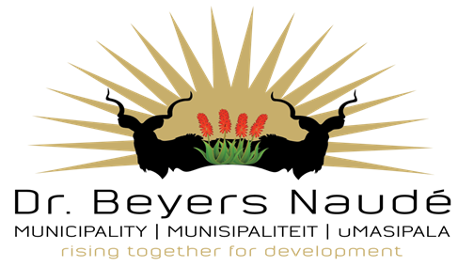

DR BEYERS NAUDE LOCAL MUNICIPALITY
REQUEST FOR PROPOSALS
PROPERTY DEVELOPMENT, CARAVAN PARK, GRAAFF REINET

Proposals are hereby invited for:

PROPERTY DEVELOPMENT, PORTION OF ERVEN 1814, CARAVAN PARK (URQUART PARK) GRAAFF-REINET

The municiplity hereby invites suitably qualified and experienced Prospective Respondents to submit written representations (“EOI Responses”) expressing their interest in the property for property development and investment purposes. Each Prospective Respondent must make their own independent assessment of the opportunity after making such investigation and taking such professional advice as they deem necessary.

The main purpose of this request is to:
- Test the market for various ways to develop the property
- To test for ideas related to property development;

All possibilities, suggestions and proposals will be considered. These include, but are not limited to:
- Multi-party agreements;
- PPP arrangements;
- Etc.

Process that will be followed subsequent to the deadline, for the Submission of Proposals:

Dr Beyers Naudé Municipality will scrutinise Proposals for ideas that could be contained in a possible follow-up Invitation to Tender. Any other recruitment process that is in line with the MFMA and / or which is supported by National Treasury might also be considered.

Individuals, companies or joint ventures might be requested to provide further details subsequent to the date of closure.
This process is not yet part of any of the above processes.

Applicable Legislation

All relevant legislation having an impact on a proposal needs to be considered.

Conditions applicable to the Submission of a Proposal

By submitting information as part of the Proposal, the owner thereof, give permission that it be used in possible future Tender documentation / Request for Qualification.

Dr Beyers Naudé Municipality, by following the RfP route, does not bind itself to any follow-up processes, but will, at its sole discretion, decide on a way forward following closing of the Proposal Period.

No political office bearer or office shall be contacted during or after the Request for Proposal period to follow up or to exercise pressure of any kind on a possible way forward.
At the sole discretion of Dr Beyers Naudé Municipality such action could lead to the exclusion of an individual, company or joint venture from a possible follow-up process.

The proposals must include the following details:
- A business model and proposed methodology;
- How the project(s) will be financed;
- Proposed property developments
- Financing structure
- How the community will benefit (economic benefit)
- A risk assessment;

Interested companys are invited to submit proposals, Property Development, Caravan Park in the tender box of the Supply Chain Management Unit, Graaff Reinet, Robert Sobukwe Building, Corner of Church Street and Oval Drive, on or before Thursday, 20th March 2025 at 12h00.

For more information, contact Mr R Deysel, 0498075700 deyselr@bnlm.gov.za

It will be required from all bidders to register on the Central Supplier Database (CSD).

DR E.M RANKWANA
MUNICIPAL MANAGER
DR BEYERS NAUDE MUNICIPALITY

