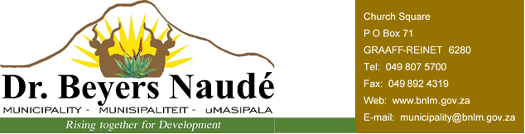

Notice is hereby given that the Dr Beyers Naudé Municipal Council has, in terms of section 24 of the Municipal Finance Management Act, No 56 of 2003, approved its annual Operational and Capital Budget, as well as reviewed and amended Integrated Development Plan (IDP) on the 29th of May 2018. As required in terms of section 17 of the Municipal Finance Management Act, the Draft 2018/19 Budget, Integrated Development Plan and Supporting Documents were tabled and advertised for representations / submissions by the local community, Provincial and National Treasury on the 27th of March 2018.

In view of the aforementioned, the following table represents an overview of the proposed 2018/19 Medium-term Revenue and Expenditure Framework:

 | Current Year | 2018/19 Medium Term Revenue and Expenditure
 | Adjusted Budget 2017/18 | Budget Year 2018/19 | Budget Year +1 2019/20 | Budget Year +2 2020/21
Total Revenue | 399 259 | 342 319 | 345 412 | 363 292
Total Expenditure | 440 304 | 366 051 | 382 392 | 404 669
Surplus / (Deficit) | (41 044) | (23 732) | (36 980) | (41 377)
Capital Expenditure | 72 179 | 44 884 | 31 647 | 30 463

Total operating revenue has decreased by 14.25% or R 56.9 million for the 2018/19 financial year, compared to the 2017/18 Adjustments Budget.

The decrease is a result of the accounting for the Cost of Free Basic Services which was accounted for as an expense in the previous financial year, whilst it should have been a reduction to revenue.

For the two outer years, operational revenue increases by 0.90% and 5.18% respectively.

Total operating expenditure for the 2018/19 financial year amounts to R 366.051 million, resulting in a budgeted deficit of R 23.732 million. Compared to the 2017/18 Adjustments Budget, operational expenditure decreased by 16.86% in the 2018/19 Budget. As mentioned this is due to the accounting treatment for Cost of Free Basic Services which was incorrect in the previous financial year.

For the two outer years, operational expenditure increases by 4.46% and 5.83% respectively. The 2019/20 and 2020/21 budgets reflect operating deficits of R 36.980 million and R 41.377 million respectively.

The following increases in property rates and service charges will be implemented with effect from 1 July 2018:

Water 6%
Sanitation 6%
Refuse 7%
Electricity (average increase in income) 7%
Property rates 6%

Further to this, the electricity tariff for residents in all towns will be standardised and converted to block-tariffs. The refuse tariff will be standardised and increased to the highest tariff currently on the tariff structure.

The approved Annual Budget containing detailed Rates and Tariffs schedules is available at the Municipal administrative units in Graaff-Reinet, Aberdeen, Nieu-Bethesda, Willowmore, Steytlerville, Rietbron, Jansenville and Klipplaat, as well as on the municipal website www.bnlm.gov.za

Dr EM Rankwana
Municipal Manager
Notice No: 58/2018

