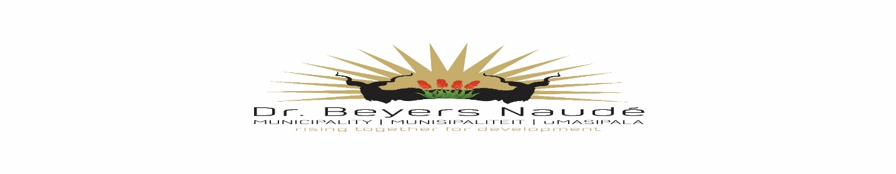

TENDER 34/2021
CLEANING OF SEWAGE PUMPSTATIONS, DRAINS, PIPELINES AND STORMWATER PIPELINES FOR A PERIOD OF 18 MONTHS
Tender documents will be available at a non-refundable deposit of R 534.00. Electronically via email. Tel nr 0498075700. e-mail: koebergb@bnlm.gov.za/jegelsr@bnlm.gov.za
Bank details are as follow: Standard Bank, Account Number 332104192, Brand Number 050116, Reference – Tender Number. Proof of payment should be provided upon tender collection.
Functionality will apply where a bidder needs to score at least 60% in order to be further evaluated
Track Record of Tenderer | 30
Delivery Time | 30
Capital (jetting machine, Supersucker etc.) Must come to Graaff Reinet and display equipment to municipality | 30

Tenders must be placed in the municipal tender box, Robert Sobukwe Building, in sealed envelopes clearly marked "TENDER 34/2021", not later than 12h00 on Monday, 6th of September 2021 and will be opened in public immediately thereafter.
Note
- Faxed, e-mailed or late quotations will not be accepted.
- Price to include VAT (if registered for vat) and disbursement costs involved with the project.
- The tender will be evaluated on 80/20 system.
- All suppliers must be registered on the CENTRAL SUPPLIER DATABASE. Log onto www.csd.gov.za for registration.
- Most recent CSD registration reports must be submitted.
- SARS Verification pins to be supplied.
- No upfront payments
- General Conditions of Contract (GCC) will apply
- Bidders should deem themselves unsuccessful if not contacted within two weeks after closing
- A current certified Municipal (rates & services) clearance certificate to be submitted.
- A current certified BBBEE status level certificate must be submitted in order to claim preference points.
- Council is not bound to accept the lowest or any tender and reserves the right to accept any tender or part thereof.
- For further details contact, Mr B. Koeberg at 049 807 5700

DR. E.M. RANKWANA
MUNICIPAL MANAGER

