INVITATION TO QUOTE: BEY SCM 324

SUPPLY AND DELIVERY OF FITTINGS (WATERWORKS)

Quotations are hereby invited from registered suppliers for the Supply and Delivery of Fittings (Waterworks) according attached bill of quantity:

Quotes must be placed in the municipal tender box, Robert Sobukwe Building, in sealed envelopes clearly marked "BEY SCM 324 ", not later than 12h00, Friday on the 22nd of July 2022 and will be opened in public immediately thereafter.
Note:
Faxed, e-mailed or late quotations will not be accepted
- The tender will be evaluated on 80/20 system.
- Price must include vat (if registered for vat) and delivery costs to Graaff-Reinet.
- All suppliers must be registered on the Central Supplier Database (CSD)
- A current original tax clearance certificate of SARS is to be submitted.
- A current certified Municipal (rates& services) clearance certificate to be submitted.
- Attached declaration of interest to be completed.
- A current certified BBBEE certificate must be submitted in order to claim preference points.
- Council is not bound to accept the lowest or any quotation and reserves the right to accept any tender or part thereof.
- For further details contact the Mrs. L. Botha

DR. E.M. RANKWANA
MUNICIPAL MANAGER

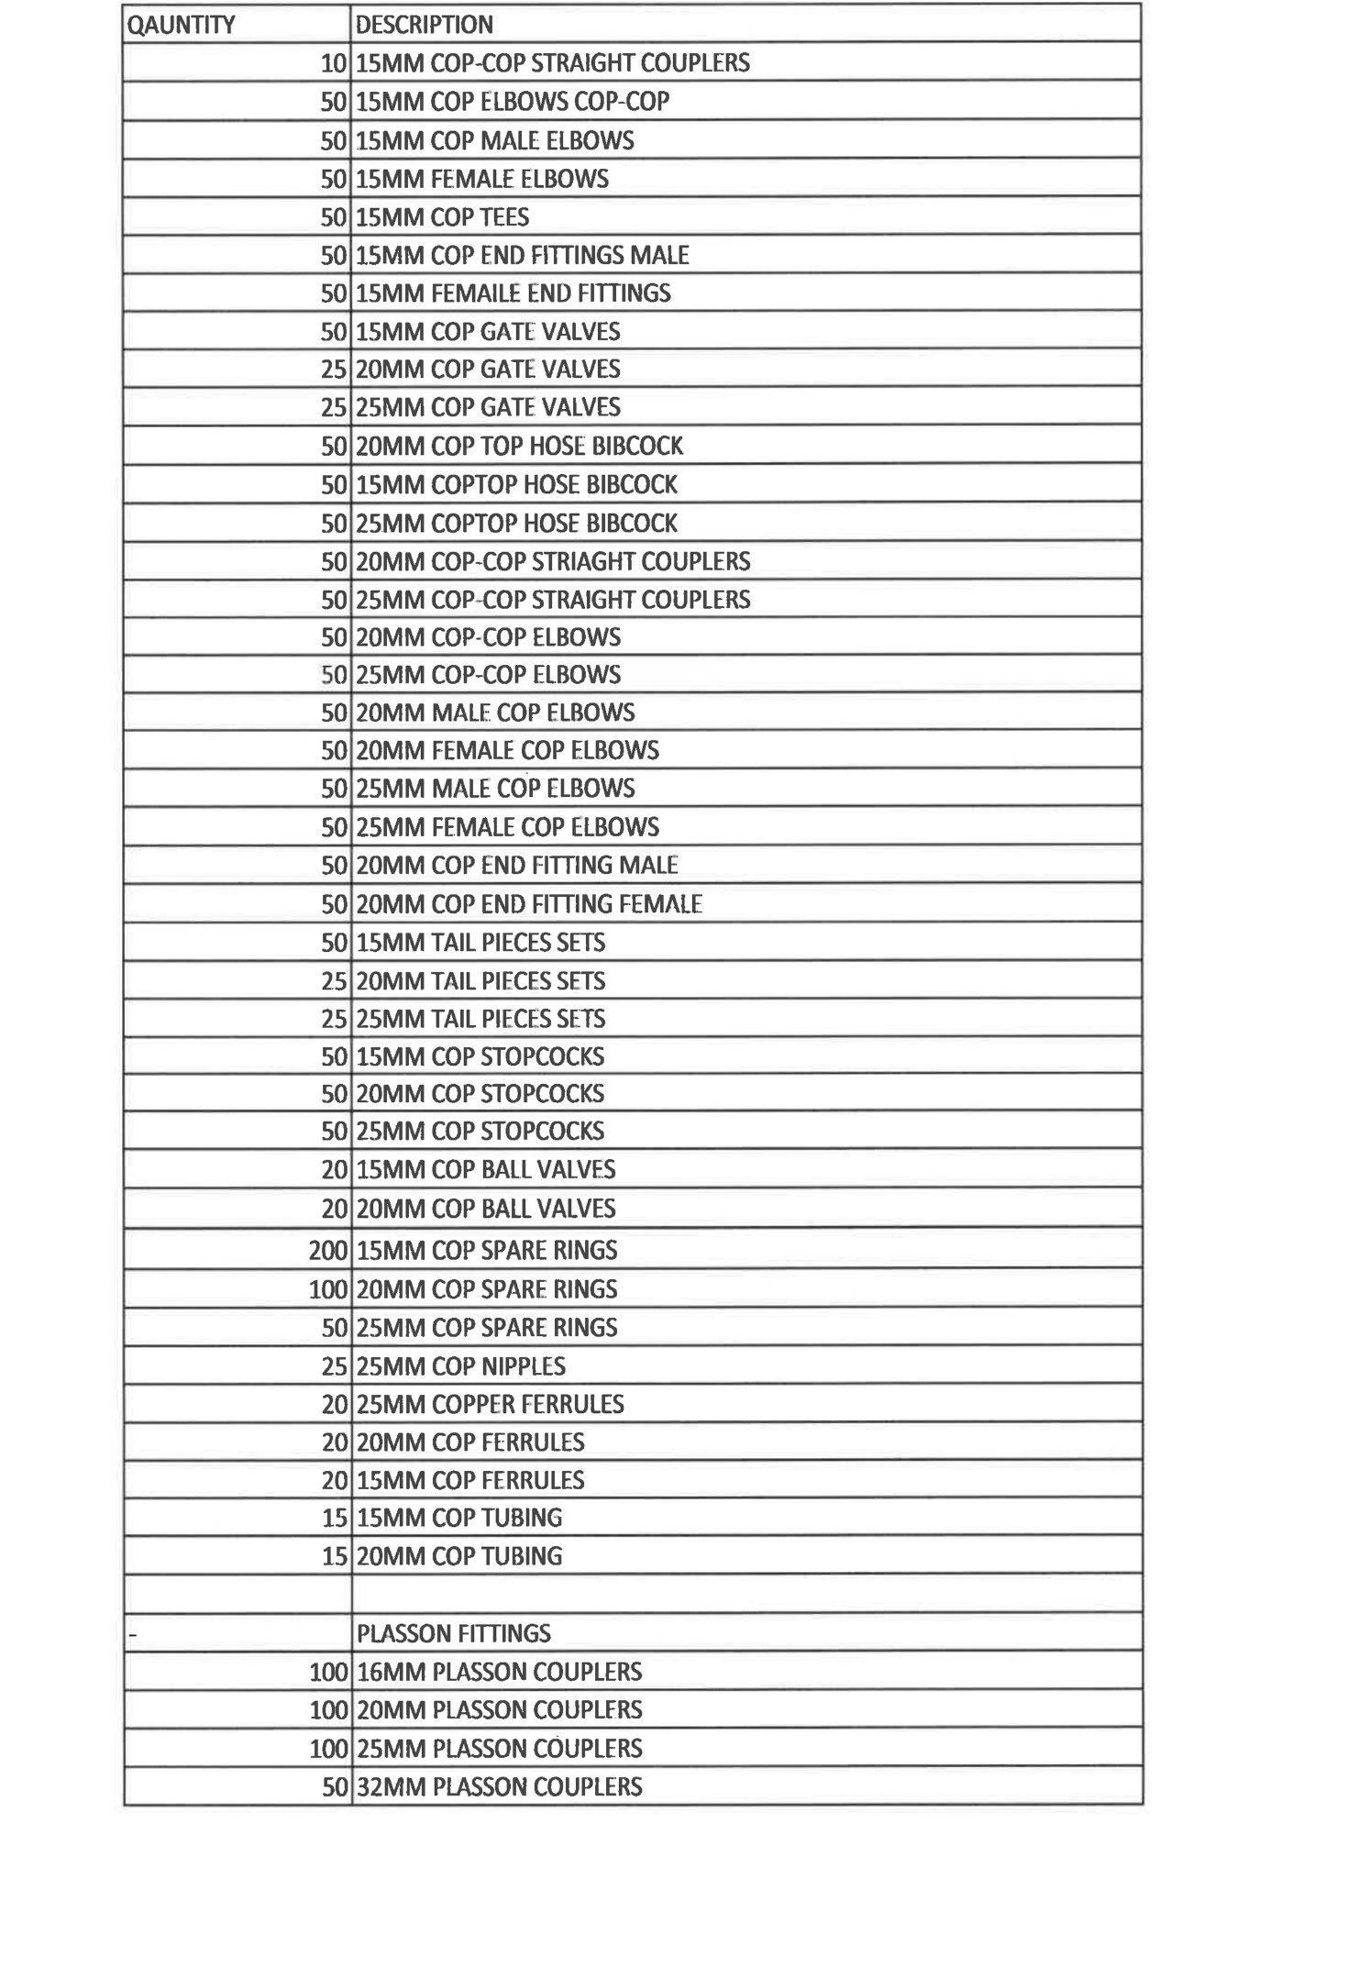
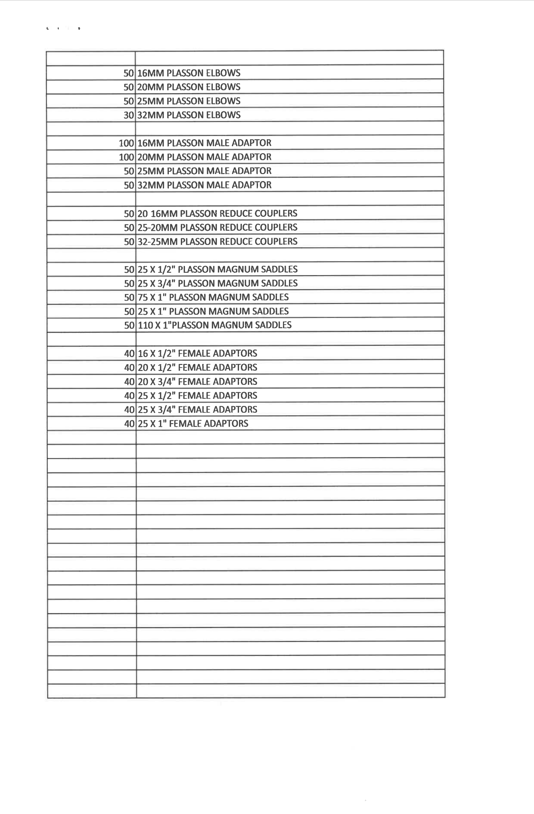

MBD 4: DECLARATION OF INTEREST

1. No bid will be accepted from persons in the service of the state∗.
- Any person, having a kinship with persons in the service of the state, including a blood relationship, may make an offer or offers in terms of this invitation to bid. In view of possible allegations of favouritism, should the resulting bid, or part thereof, be awarded to persons connected with or related to persons in service of the state, it is required that the bidder or their authorised representative declare their position in relation to the evaluating/adjudicating authority and/or take an oath declaring his/her interest.

3 In order to give effect to the above, the following questionnaire must be completed and submitted with the bid.

3.1 Full Name: …………………………………………………………………………

3.2 Identity Number: …………………………………………………………………

3.3 Company Registration Number: …………………………………………………

3.4 Tax Reference Number: …………………………………………………………

3.5 VAT Registration Number: ………………………………………………………

3.6 Are you presently in the service of the state∗ YES / NO

3.6.1 If so, furnish particulars.
………………………………………………………………

………………………………………………………………

3.7 Have you been in the service of the state for the past YES / NO
twelve months?

    - If so, furnish particulars.

………………………………………………………………

………………………………………………………………

3.8 Do you, have any relationship (family, friend, other) with persons in the service of the state and who may be involved with the evaluation and or adjudication of this bid?

3.8.1 If so, furnish particulars.

………………………………………………………………

………………………………………………………………

3.9 Are you, aware of any relationship (family, friend, other) between a bidder and any persons in the service of the state who may be involved with the evaluation and or adjudication of this bid?

3.9.1 If so, furnish particulars

…………………………………………………………….

…………………………………………………………….

YES / NO

YES / NO

3.10 Are any of the company’s directors, managers, principal YES / NO
shareholders or stakeholders in service of the state?

3.10.1 If so, furnish particulars.

………………………………………………………………

………………………………………………………………

  - Are any spouse, child or parent of the company’s directors, YES / NO
managers, principal shareholders or stakeholders in service
of the state?

3.11.1 If so, furnish particulars.

………………………………………………………………

………………………………………………………………

CERTIFICATION

I, THE UNDERSIGNED (NAME) ………………………………………………………………………
CERTIFY THAT THE INFORMATION FURNISHED ON THIS DECLARATION FORM IS CORRECT.

I ACCEPT THAT THE STATE MAY ACT AGAINST ME SHOULD THIS DECLARATION PROVE TO BE

FALSE.

Signature Date

……………………………………… …………………………………………………………
Position Name of Bidder

∗ MSCM Regulations: “in the service of the state” means to be – - a member of – - any municipal council; - any provincial legislature; or - the national Assembly or the national Council of provinces; - a member of the board of directors of any municipal entity; - an official of any municipality or municipal entity; - an employee of any national or provincial department, national or provincial public entity or constitutional institution within the meaning of the Public Finance Management Act, 1999 (Act No.1 of 1999); - a member of the accounting authority of any national or provincial public entity; or - an employee of Parliament or a provincial legislature.

